ЛЕТНЕЕ

ДОМАШНЕЕ

ЗАДАНИЕ

*« Я готовлюсь*

*к 3 классу»*

Фамилия___________________

Имя_______________________

Отчество __________________

Начало работы в тетради___________________

Я закончил заниматься _______________ Ура!!!

г. Сургут

2023

**Работа № 1.**

*Прочитай. Запиши предложения , вставляя пропущенные буквы.*

У Буратино длинный н . с. Он н .с золотой ключик папе Карло. Юра м . л, но он хорошо м . л глину для своих фигурок. Мастер открыл л . к.Мама вырастила зеленый л . к.

*Подчеркни слова, в которых звуков больше, чем букв.*

____________________________________________________________________________________________________________________________________________________________________________________________________________________________________________________________________________________________________________

*Задача.*

Один мальчик поймал 15 раков, а другой 12. На сколько раков первый мальчик поймал больше второго?

|  |  |  |  |  |  |  |  |  |  |  |  |  |  |  |  |  |  |  |  |  |  |  |  |  |  |  |  |  |
| --- | --- | --- | --- | --- | --- | --- | --- | --- | --- | --- | --- | --- | --- | --- | --- | --- | --- | --- | --- | --- | --- | --- | --- | --- | --- | --- | --- | --- |
|  |  |  |  |  |  |  |  |  |  |  |  |  |  |  |  |  |  |  |  |  |  |  |  |  |  |  |  |  |
|  |  |  |  |  |  |  |  |  |  |  |  |  |  |  |  |  |  |  |  |  |  |  |  |  |  |  |  |  |
|  |  |  |  |  |  |  |  |  |  |  |  |  |  |  |  |  |  |  |  |  |  |  |  |  |  |  |  |  |
|  |  |  |  |  |  |  |  |  |  |  |  |  |  |  |  |  |  |  |  |  |  |  |  |  |  |  |  |  |
|  |  |  |  |  |  |  |  |  |  |  |  |  |  |  |  |  |  |  |  |  |  |  |  |  |  |  |  |  |
|  |  |  |  |  |  |  |  |  |  |  |  |  |  |  |  |  |  |  |  |  |  |  |  |  |  |  |  |  |
|  |  |  |  |  |  |  |  |  |  |  |  |  |  |  |  |  |  |  |  |  |  |  |  |  |  |  |  |  |

*Реши.*

45-30= 88-19= 15-(3+5)=

17+32= 16+80= 8+(12-5)=

**Работа №2**

*Прочитай. Спиши. Вместо точек подбери подходящие по смыслу слова.*

Вот и …... Поплыл мой кораблик в ….. даль. Он мелькнул крохотной ….и скрылся. Может, до моря синего доплы­вет.

*Слова для справок: речка, речную, точкой.*

________________________________________________________________________________________________________________________________________________________________________________________________________________________________________________________________________________________________________________________________________________________________________

*Задача*

У мамы было 19 гвоздик. Потом ей подарили ещё 6 гвоздики. Сколько гвоздик стало у мамы?

|  |  |  |  |  |  |  |  |  |  |  |  |  |  |  |  |  |  |  |  |  |  |  |  |  |  |  |  |  |
| --- | --- | --- | --- | --- | --- | --- | --- | --- | --- | --- | --- | --- | --- | --- | --- | --- | --- | --- | --- | --- | --- | --- | --- | --- | --- | --- | --- | --- |
|  |  |  |  |  |  |  |  |  |  |  |  |  |  |  |  |  |  |  |  |  |  |  |  |  |  |  |  |  |
|  |  |  |  |  |  |  |  |  |  |  |  |  |  |  |  |  |  |  |  |  |  |  |  |  |  |  |  |  |
|  |  |  |  |  |  |  |  |  |  |  |  |  |  |  |  |  |  |  |  |  |  |  |  |  |  |  |  |  |
|  |  |  |  |  |  |  |  |  |  |  |  |  |  |  |  |  |  |  |  |  |  |  |  |  |  |  |  |  |
|  |  |  |  |  |  |  |  |  |  |  |  |  |  |  |  |  |  |  |  |  |  |  |  |  |  |  |  |  |
|  |  |  |  |  |  |  |  |  |  |  |  |  |  |  |  |  |  |  |  |  |  |  |  |  |  |  |  |  |
|  |  |  |  |  |  |  |  |  |  |  |  |  |  |  |  |  |  |  |  |  |  |  |  |  |  |  |  |  |

*Реши*

70+28= 51-13= 13+20+7=

52+11= 64-15= 41+8+19=

80-34= 29+14= 53-28+48=

**Работа № 3**

*Прочитай, из слов каждой строки составь предложение и запиши. Подчеркни однокоренные слова.*

закружился, первый, воздухе, снег, в.

он, лесную, тихо, на, ложился, полянку,

зайчишка, на, сидел, пеньке, лапой, ловил, снежинки, и .

____________________________________________________________________________________________________________________________________________________________________________________________________________________________________________________________________________________________________________________________

*Задача.*

У Миши 20 наклеек, а у Игоря на 4 на­клейки больше. Сколько всего наклеек у мальчиков?

|  |  |  |  |  |  |  |  |  |  |  |  |  |  |  |  |  |  |  |  |  |  |  |  |  |  |  |  |  |
| --- | --- | --- | --- | --- | --- | --- | --- | --- | --- | --- | --- | --- | --- | --- | --- | --- | --- | --- | --- | --- | --- | --- | --- | --- | --- | --- | --- | --- |
|  |  |  |  |  |  |  |  |  |  |  |  |  |  |  |  |  |  |  |  |  |  |  |  |  |  |  |  |  |
|  |  |  |  |  |  |  |  |  |  |  |  |  |  |  |  |  |  |  |  |  |  |  |  |  |  |  |  |  |
|  |  |  |  |  |  |  |  |  |  |  |  |  |  |  |  |  |  |  |  |  |  |  |  |  |  |  |  |  |
|  |  |  |  |  |  |  |  |  |  |  |  |  |  |  |  |  |  |  |  |  |  |  |  |  |  |  |  |  |
|  |  |  |  |  |  |  |  |  |  |  |  |  |  |  |  |  |  |  |  |  |  |  |  |  |  |  |  |  |
|  |  |  |  |  |  |  |  |  |  |  |  |  |  |  |  |  |  |  |  |  |  |  |  |  |  |  |  |  |
|  |  |  |  |  |  |  |  |  |  |  |  |  |  |  |  |  |  |  |  |  |  |  |  |  |  |  |  |  |

*Вставь пропущенные числа.*

60-…..=54 …….+8=30 40+…..>85+5

…..-30=33 12+….=21 79-2<80-……

**Работа № 4.**

*Прочитай, спиши, вставляя пропущенные буквы. Найди однокоренные слова и выделите корень.*

Наш... мыш.. построили новый дом. На в..ротах написали: "Во дворе злая с..бака Жуч...ка". Кошки обх..дили ст..роной мыш..нный дом.

________________________________________________________________________________________________________________________________________________________________________________________________________________________________________________________________________________________________________________________

*Задача.*

На даче росли 19 кустов смородины. Посади­ли ещё 16 кустов. Сколько кустов смородины стало на даче?

|  |  |  |  |  |  |  |  |  |  |  |  |  |  |  |  |  |  |  |  |  |  |  |  |  |  |  |  |  |
| --- | --- | --- | --- | --- | --- | --- | --- | --- | --- | --- | --- | --- | --- | --- | --- | --- | --- | --- | --- | --- | --- | --- | --- | --- | --- | --- | --- | --- |
|  |  |  |  |  |  |  |  |  |  |  |  |  |  |  |  |  |  |  |  |  |  |  |  |  |  |  |  |  |
|  |  |  |  |  |  |  |  |  |  |  |  |  |  |  |  |  |  |  |  |  |  |  |  |  |  |  |  |  |
|  |  |  |  |  |  |  |  |  |  |  |  |  |  |  |  |  |  |  |  |  |  |  |  |  |  |  |  |  |
|  |  |  |  |  |  |  |  |  |  |  |  |  |  |  |  |  |  |  |  |  |  |  |  |  |  |  |  |  |
|  |  |  |  |  |  |  |  |  |  |  |  |  |  |  |  |  |  |  |  |  |  |  |  |  |  |  |  |  |
|  |  |  |  |  |  |  |  |  |  |  |  |  |  |  |  |  |  |  |  |  |  |  |  |  |  |  |  |  |
|  |  |  |  |  |  |  |  |  |  |  |  |  |  |  |  |  |  |  |  |  |  |  |  |  |  |  |  |  |

*Реши выражения*

10-8+5= 15-(13-8)=

16+3-4= 10+(12-4)=

*Поставь знаки +,-*

4__3__2=5 10__7__5=8 2__8__4=6 9__3__4=10

**Работа № 5.**

*Прочитай, из слов каждой строки составь и запиши предложение. Подчеркни грамматическую основу.*

на, крыльце, рыжий, Васька, кот, спал, .

выскочили, из, мышата, норки.

Васька, открыл, глаза, и, к, мышатам, прыгнул.

умчались, они, в, быстро, норку.

рот, кот, только, раскрыл.

________________________________________________________________________________________________________________________________________________________________________________________________________________________________________________________________________________________________________________

*Задачи.*

Леший сделал 27 ловушек для зверей и 8 для птиц. Вовочка 33 из них обезвредил. Сколько ловушек осталось?

|  |  |  |  |  |  |  |  |  |  |  |  |  |  |  |  |  |  |  |  |  |  |  |  |  |  |  |  |  |  |
| --- | --- | --- | --- | --- | --- | --- | --- | --- | --- | --- | --- | --- | --- | --- | --- | --- | --- | --- | --- | --- | --- | --- | --- | --- | --- | --- | --- | --- | --- |
|  |  |  |  |  |  |  |  |  |  |  |  |  |  |  |  |  |  |  |  |  |  |  |  |  |  |  |  |  |  |
|  |  |  |  |  |  |  |  |  |  |  |  |  |  |  |  |  |  |  |  |  |  |  |  |  |  |  |  |  |  |
|  |  |  |  |  |  |  |  |  |  |  |  |  |  |  |  |  |  |  |  |  |  |  |  |  |  |  |  |  |  |
|  |  |  |  |  |  |  |  |  |  |  |  |  |  |  |  |  |  |  |  |  |  |  |  |  |  |  |  |  |  |
|  |  |  |  |  |  |  |  |  |  |  |  |  |  |  |  |  |  |  |  |  |  |  |  |  |  |  |  |  |  |
|  |  |  |  |  |  |  |  |  |  |  |  |  |  |  |  |  |  |  |  |  |  |  |  |  |  |  |  |  |  |
|  |  |  |  |  |  |  |  |  |  |  |  |  |  |  |  |  |  |  |  |  |  |  |  |  |  |  |  |  |  |

*Поставь знаки < >*

15-5___18-6 25*0___26*1 12+12____ 12*2 16+2___19-7

*Реши.*

30+5-10-20+7-9+20= 15-8+10-9+4-7+6= 20+48+7-13-21+10=

**Работа № 6**

*Прочитай и запиши, расположив предложения так, чтобы получился связный рассказ.*

Поднялся сильный ветер.

Мальчик подвязал яблоньку.

Около дома росла маленькая яблонька.

Он стал её крутить и ломать.

Расти, яблонька!

________________________________________________________________________________________________________________________________________________________________________________________________________________________________________________________________________________________________________

*Задача*

Аня купила 4 набора открыток по 3 открытки в каждом. Сколько всего открыток купила мама?

|  |  |  |  |  |  |  |  |  |  |  |  |  |  |  |  |  |  |  |  |  |  |  |  |  |  |  |  |  |  |
| --- | --- | --- | --- | --- | --- | --- | --- | --- | --- | --- | --- | --- | --- | --- | --- | --- | --- | --- | --- | --- | --- | --- | --- | --- | --- | --- | --- | --- | --- |
|  |  |  |  |  |  |  |  |  |  |  |  |  |  |  |  |  |  |  |  |  |  |  |  |  |  |  |  |  |  |
|  |  |  |  |  |  |  |  |  |  |  |  |  |  |  |  |  |  |  |  |  |  |  |  |  |  |  |  |  |  |
|  |  |  |  |  |  |  |  |  |  |  |  |  |  |  |  |  |  |  |  |  |  |  |  |  |  |  |  |  |  |
|  |  |  |  |  |  |  |  |  |  |  |  |  |  |  |  |  |  |  |  |  |  |  |  |  |  |  |  |  |  |
|  |  |  |  |  |  |  |  |  |  |  |  |  |  |  |  |  |  |  |  |  |  |  |  |  |  |  |  |  |  |
|  |  |  |  |  |  |  |  |  |  |  |  |  |  |  |  |  |  |  |  |  |  |  |  |  |  |  |  |  |  |
|  |  |  |  |  |  |  |  |  |  |  |  |  |  |  |  |  |  |  |  |  |  |  |  |  |  |  |  |  |  |

*Запиши и реши удобным способом:*

36-(10+16)= ___________________ 87-( 20+17)= _________________________

(54 + 32) – 24= _________________ ( 67+21)-37= _________________________

89-(19+20)= ____________________ (52+19)-32= _________________________

**Работа № 7.**

*Прочитай, запиши слова парами, например: ряд-ряды.*

з...мля, св...ча, в...дро, оз...ро, в...лна, в....ело, д...жди, р...ды, тр..ва, м..ря,

травы, ряд, вёсла, море, свечи, земли, озера, дождь, волны, вёдра.

____________________________________________________________________________________________________________________________________________________________________________________________________________________________________________________________________________________________________________________________________________________

*Задача.*

Мама купила 12 пирожных, и разложила их на 2 тарелки. Сколько пирожных на одной тарелке?

|  |  |  |  |  |  |  |  |  |  |  |  |  |  |  |  |  |  |  |  |  |  |  |  |  |  |  |  |  |
| --- | --- | --- | --- | --- | --- | --- | --- | --- | --- | --- | --- | --- | --- | --- | --- | --- | --- | --- | --- | --- | --- | --- | --- | --- | --- | --- | --- | --- |
|  |  |  |  |  |  |  |  |  |  |  |  |  |  |  |  |  |  |  |  |  |  |  |  |  |  |  |  |  |
|  |  |  |  |  |  |  |  |  |  |  |  |  |  |  |  |  |  |  |  |  |  |  |  |  |  |  |  |  |
|  |  |  |  |  |  |  |  |  |  |  |  |  |  |  |  |  |  |  |  |  |  |  |  |  |  |  |  |  |
|  |  |  |  |  |  |  |  |  |  |  |  |  |  |  |  |  |  |  |  |  |  |  |  |  |  |  |  |  |
|  |  |  |  |  |  |  |  |  |  |  |  |  |  |  |  |  |  |  |  |  |  |  |  |  |  |  |  |  |
|  |  |  |  |  |  |  |  |  |  |  |  |  |  |  |  |  |  |  |  |  |  |  |  |  |  |  |  |  |
|  |  |  |  |  |  |  |  |  |  |  |  |  |  |  |  |  |  |  |  |  |  |  |  |  |  |  |  |  |

*Реши примеры:*

53+5+22= 39+10+11= 25-8+3= 90-32+19=

*Поставь знаки < >=*

45см___ 4дм 98-30 __ 35+20 78__ 65+( 12-8) 26см___3дм

**Работа №8**

*Составь и запиши предложения.*

*кто?* ребята ___________________________________________

— шепчутся

*ЧТО?* камыши_________________________________________

*кто?* сосульки __________________________________________

— плачут

*ЧТО ?* малыши ___________________________________________

*Задача.*

У девочки было 10 марок. Она наклеила их на 5 конвертов. Сколько конвертов она отправила?

|  |  |  |  |  |  |  |  |  |  |  |  |  |  |  |  |  |  |  |  |  |  |  |  |  |  |  |  |  |
| --- | --- | --- | --- | --- | --- | --- | --- | --- | --- | --- | --- | --- | --- | --- | --- | --- | --- | --- | --- | --- | --- | --- | --- | --- | --- | --- | --- | --- |
|  |  |  |  |  |  |  |  |  |  |  |  |  |  |  |  |  |  |  |  |  |  |  |  |  |  |  |  |  |
|  |  |  |  |  |  |  |  |  |  |  |  |  |  |  |  |  |  |  |  |  |  |  |  |  |  |  |  |  |
|  |  |  |  |  |  |  |  |  |  |  |  |  |  |  |  |  |  |  |  |  |  |  |  |  |  |  |  |  |
|  |  |  |  |  |  |  |  |  |  |  |  |  |  |  |  |  |  |  |  |  |  |  |  |  |  |  |  |  |
|  |  |  |  |  |  |  |  |  |  |  |  |  |  |  |  |  |  |  |  |  |  |  |  |  |  |  |  |  |
|  |  |  |  |  |  |  |  |  |  |  |  |  |  |  |  |  |  |  |  |  |  |  |  |  |  |  |  |  |
|  |  |  |  |  |  |  |  |  |  |  |  |  |  |  |  |  |  |  |  |  |  |  |  |  |  |  |  |  |

*Продолжи логический ряд*

24, 33, 28, 30, 39,______________________________________________

*Запиши выражение:*

Найди сумму чисел 47 и 13 и уменьши на 9__________________________________

Из числа 50 вычесть разность чисел 12 и 8 __________________________________

Из произведения чисел 5 и 3 вычесть 12 ____________________________________

К частному чисел 18 и 6 прибавить 45 ______________________________________

**Работа № 9.**

*Прочитай, Подбери слова предметы к которым можно было бы отнести эти действия:*

______________ ползёт. ______________ тащится. _______________мчится.

________________лают. _________________каркает. __________________ухает.

____________мурлычет. _______________гудит. _________________ смеются.

*Задача.*

Бабушка угостила 6 внуков пирожками. Каждому дала по 2 пирожка. Сколько пирожков испекла бабушка?

|  |  |  |  |  |  |  |  |  |  |  |  |  |  |  |  |  |  |  |  |  |  |  |  |  |  |  |  |  |  |
| --- | --- | --- | --- | --- | --- | --- | --- | --- | --- | --- | --- | --- | --- | --- | --- | --- | --- | --- | --- | --- | --- | --- | --- | --- | --- | --- | --- | --- | --- |
|  |  |  |  |  |  |  |  |  |  |  |  |  |  |  |  |  |  |  |  |  |  |  |  |  |  |  |  |  |  |
|  |  |  |  |  |  |  |  |  |  |  |  |  |  |  |  |  |  |  |  |  |  |  |  |  |  |  |  |  |  |
|  |  |  |  |  |  |  |  |  |  |  |  |  |  |  |  |  |  |  |  |  |  |  |  |  |  |  |  |  |  |
|  |  |  |  |  |  |  |  |  |  |  |  |  |  |  |  |  |  |  |  |  |  |  |  |  |  |  |  |  |  |
|  |  |  |  |  |  |  |  |  |  |  |  |  |  |  |  |  |  |  |  |  |  |  |  |  |  |  |  |  |  |
|  |  |  |  |  |  |  |  |  |  |  |  |  |  |  |  |  |  |  |  |  |  |  |  |  |  |  |  |  |  |
|  |  |  |  |  |  |  |  |  |  |  |  |  |  |  |  |  |  |  |  |  |  |  |  |  |  |  |  |  |  |

*Сосчитай пример с именованными числами:*

2см 3мм + 3см 5мм = _________________________________

6дм 4 см – 5 дм = _____________________________________

7см – 6см 8 мм =______________________________________

32см + 68см=_______________________________________

*Продолжи логический ряд.*

9,18,27________________________________________________

**Работа № 10.**

*Прочитай. Запиши цепочку родственных слов, выдели корень, основу слова, окончание.*

Гриб, грибник, _____________________________________________________________

Зерно, ____________________________________________________________________

Корм, __________________________________________________________________

Дом, ____________________________________________________________________

Мороз, __________________________________________________________________

*Задача.*

У продавца было 50 лимонов. Сначала он продал 18 лимонов, а потом ещё 9. сколько осталось лимонов?

|  |  |  |  |  |  |  |  |  |  |  |  |  |  |  |  |  |  |  |  |  |  |  |  |  |  |  |  |  |
| --- | --- | --- | --- | --- | --- | --- | --- | --- | --- | --- | --- | --- | --- | --- | --- | --- | --- | --- | --- | --- | --- | --- | --- | --- | --- | --- | --- | --- |
|  |  |  |  |  |  |  |  |  |  |  |  |  |  |  |  |  |  |  |  |  |  |  |  |  |  |  |  |  |
|  |  |  |  |  |  |  |  |  |  |  |  |  |  |  |  |  |  |  |  |  |  |  |  |  |  |  |  |  |
|  |  |  |  |  |  |  |  |  |  |  |  |  |  |  |  |  |  |  |  |  |  |  |  |  |  |  |  |  |
|  |  |  |  |  |  |  |  |  |  |  |  |  |  |  |  |  |  |  |  |  |  |  |  |  |  |  |  |  |
|  |  |  |  |  |  |  |  |  |  |  |  |  |  |  |  |  |  |  |  |  |  |  |  |  |  |  |  |  |
|  |  |  |  |  |  |  |  |  |  |  |  |  |  |  |  |  |  |  |  |  |  |  |  |  |  |  |  |  |
|  |  |  |  |  |  |  |  |  |  |  |  |  |  |  |  |  |  |  |  |  |  |  |  |  |  |  |  |  |

*Реши столбиком, сделай проверку.*

36+18 70-38 83-25 39+36

|  |  |  |  |  |  |  |  |  |  |  |  |  |  |  |  |  |  |  |  |  |  |  |  |  |  |  |  |  |
| --- | --- | --- | --- | --- | --- | --- | --- | --- | --- | --- | --- | --- | --- | --- | --- | --- | --- | --- | --- | --- | --- | --- | --- | --- | --- | --- | --- | --- |
|  |  |  |  |  |  |  |  |  |  |  |  |  |  |  |  |  |  |  |  |  |  |  |  |  |  |  |  |  |
|  |  |  |  |  |  |  |  |  |  |  |  |  |  |  |  |  |  |  |  |  |  |  |  |  |  |  |  |  |
|  |  |  |  |  |  |  |  |  |  |  |  |  |  |  |  |  |  |  |  |  |  |  |  |  |  |  |  |  |

**Работа № 11.**

*Прочитай. Спиши. Вставь пропущенные буквы. Подчеркни грамматическую основу предложения. В 1, 2 предложении найди словосочетания.*

Нагрянул в лес суровый январь. На кус­ты сугро..ы намёл. Д..ревья инеем опуш..л. Сн..га да морозы царствуют в лесу. Вот проб..жала л..са. Её сл..ды ведут в ч..щу.

____________________________________________________________________________________________________________________________________________________________________________________________________________________________________________________________________________________________________________________________

*Задача.*

На одной тарелке 5 пельменей. Сколько пельменей на 4 тарелках?

|  |  |  |  |  |  |  |  |  |  |  |  |  |  |  |  |  |  |  |  |  |  |  |  |  |  |  |  |  |
| --- | --- | --- | --- | --- | --- | --- | --- | --- | --- | --- | --- | --- | --- | --- | --- | --- | --- | --- | --- | --- | --- | --- | --- | --- | --- | --- | --- | --- |
|  |  |  |  |  |  |  |  |  |  |  |  |  |  |  |  |  |  |  |  |  |  |  |  |  |  |  |  |  |
|  |  |  |  |  |  |  |  |  |  |  |  |  |  |  |  |  |  |  |  |  |  |  |  |  |  |  |  |  |
|  |  |  |  |  |  |  |  |  |  |  |  |  |  |  |  |  |  |  |  |  |  |  |  |  |  |  |  |  |
|  |  |  |  |  |  |  |  |  |  |  |  |  |  |  |  |  |  |  |  |  |  |  |  |  |  |  |  |  |
|  |  |  |  |  |  |  |  |  |  |  |  |  |  |  |  |  |  |  |  |  |  |  |  |  |  |  |  |  |
|  |  |  |  |  |  |  |  |  |  |  |  |  |  |  |  |  |  |  |  |  |  |  |  |  |  |  |  |  |
|  |  |  |  |  |  |  |  |  |  |  |  |  |  |  |  |  |  |  |  |  |  |  |  |  |  |  |  |  |

*Реши уравнения.*

35-Х=17 Х*3=21 Х+41=90

|  |  |  |  |  |  |  |  |  |  |  |  |  |  |  |  |  |  |  |  |  |  |  |  |  |  |  |  |  |
| --- | --- | --- | --- | --- | --- | --- | --- | --- | --- | --- | --- | --- | --- | --- | --- | --- | --- | --- | --- | --- | --- | --- | --- | --- | --- | --- | --- | --- |
|  |  |  |  |  |  |  |  |  |  |  |  |  |  |  |  |  |  |  |  |  |  |  |  |  |  |  |  |  |
|  |  |  |  |  |  |  |  |  |  |  |  |  |  |  |  |  |  |  |  |  |  |  |  |  |  |  |  |  |
|  |  |  |  |  |  |  |  |  |  |  |  |  |  |  |  |  |  |  |  |  |  |  |  |  |  |  |  |  |
|  |  |  |  |  |  |  |  |  |  |  |  |  |  |  |  |  |  |  |  |  |  |  |  |  |  |  |  |  |
|  |  |  |  |  |  |  |  |  |  |  |  |  |  |  |  |  |  |  |  |  |  |  |  |  |  |  |  |  |
|  |  |  |  |  |  |  |  |  |  |  |  |  |  |  |  |  |  |  |  |  |  |  |  |  |  |  |  |  |

**Работа № 12.**

*Прочитай. Спиши.*

В нашем языке сотни тысяч сло... . На первом месте стоит слово хле... . Много пословиц сложил русский наро... о хле­бе. Хле.. всему голова!

______________________________________________________________________________________________________________________________________________________________________________________________________________________________________________________________________________________________________________________

*Задача.*

В кассе учатся 27 детей. 18 мальчиков. Сколько девочек учатся в классе?

|  |  |  |  |  |  |  |  |  |  |  |  |  |  |  |  |  |  |  |  |  |  |  |  |  |  |  |  |  |
| --- | --- | --- | --- | --- | --- | --- | --- | --- | --- | --- | --- | --- | --- | --- | --- | --- | --- | --- | --- | --- | --- | --- | --- | --- | --- | --- | --- | --- |
|  |  |  |  |  |  |  |  |  |  |  |  |  |  |  |  |  |  |  |  |  |  |  |  |  |  |  |  |  |
|  |  |  |  |  |  |  |  |  |  |  |  |  |  |  |  |  |  |  |  |  |  |  |  |  |  |  |  |  |
|  |  |  |  |  |  |  |  |  |  |  |  |  |  |  |  |  |  |  |  |  |  |  |  |  |  |  |  |  |
|  |  |  |  |  |  |  |  |  |  |  |  |  |  |  |  |  |  |  |  |  |  |  |  |  |  |  |  |  |
|  |  |  |  |  |  |  |  |  |  |  |  |  |  |  |  |  |  |  |  |  |  |  |  |  |  |  |  |  |

*Реши примеры столбиком с проверкой.*

29+19 90-78 55+45 48+18

|  |  |  |  |  |  |  |  |  |  |  |  |  |  |  |  |  |  |  |  |  |  |  |  |  |  |  |  |  |
| --- | --- | --- | --- | --- | --- | --- | --- | --- | --- | --- | --- | --- | --- | --- | --- | --- | --- | --- | --- | --- | --- | --- | --- | --- | --- | --- | --- | --- |
|  |  |  |  |  |  |  |  |  |  |  |  |  |  |  |  |  |  |  |  |  |  |  |  |  |  |  |  |  |
|  |  |  |  |  |  |  |  |  |  |  |  |  |  |  |  |  |  |  |  |  |  |  |  |  |  |  |  |  |
|  |  |  |  |  |  |  |  |  |  |  |  |  |  |  |  |  |  |  |  |  |  |  |  |  |  |  |  |  |
|  |  |  |  |  |  |  |  |  |  |  |  |  |  |  |  |  |  |  |  |  |  |  |  |  |  |  |  |  |

*Продолжи логический ряд.*

6,12,18,________________________________________________

21,28,35_______________________________________________

**Работа № 13.**

*Прочитай Выпиши сначала слова с Ь – показателем мягкости, затем слова где Ь – разделительный.*

Лошадь, друзья, конь, медведь, семья, колья, кисть, уголь, кольцо, вьюга, пальто, письмо, варенье, деревья, львица, коньки, альбом, обезьяна.

____________________________________________________________________________________________________________________________________________________________________________________________________________________________________________________________________________________________________________________________

*Задача*

В гараже было 21автобус и 19 маршруток. 15 машин уехало. Сколько в гараже осталось машин всего?

|  |  |  |  |  |  |  |  |  |  |  |  |  |  |  |  |  |  |  |  |  |  |  |  |  |  |  |  |  |
| --- | --- | --- | --- | --- | --- | --- | --- | --- | --- | --- | --- | --- | --- | --- | --- | --- | --- | --- | --- | --- | --- | --- | --- | --- | --- | --- | --- | --- |
|  |  |  |  |  |  |  |  |  |  |  |  |  |  |  |  |  |  |  |  |  |  |  |  |  |  |  |  |  |
|  |  |  |  |  |  |  |  |  |  |  |  |  |  |  |  |  |  |  |  |  |  |  |  |  |  |  |  |  |
|  |  |  |  |  |  |  |  |  |  |  |  |  |  |  |  |  |  |  |  |  |  |  |  |  |  |  |  |  |
|  |  |  |  |  |  |  |  |  |  |  |  |  |  |  |  |  |  |  |  |  |  |  |  |  |  |  |  |  |
|  |  |  |  |  |  |  |  |  |  |  |  |  |  |  |  |  |  |  |  |  |  |  |  |  |  |  |  |  |
|  |  |  |  |  |  |  |  |  |  |  |  |  |  |  |  |  |  |  |  |  |  |  |  |  |  |  |  |  |
|  |  |  |  |  |  |  |  |  |  |  |  |  |  |  |  |  |  |  |  |  |  |  |  |  |  |  |  |  |

*Сравни.> < =*

12*4…..5*12 70:10….7*10 13*0…13+1 12+3…12*2

а*1…а*0 250*а…250-а в-12….в-21 196-а….156-а

*Продолжи логический ряд.( 5 чисел)*

308, 312, 316_______________________________________________

**Работа № 14.**

*Прочитай. Расположи предложения так, чтобы получился связ­ный текст. Озаглавь его.*

Мишка залег в берлогу до весны.

Снежок занесет тропу в медвежий дом.

Он натаскал в свое жилье душистой хвои.

У старой сосны медведь выбрал место для берлоги.

**____________________________________________________________________________________________________________________________________________________________________________________________________________________________________________________________________________________________________________________________**

*Задача.*

Дети собрали 60 кг яблок. Миша собрал 21 кг, а Соня на 6 кг меньше. Остальные яблоки собрал Денис. Сколько кг яблок собрал Денис?

|  |  |  |  |  |  |  |  |  |  |  |  |  |  |  |  |  |  |  |  |  |  |  |  |  |  |  |  |  |
| --- | --- | --- | --- | --- | --- | --- | --- | --- | --- | --- | --- | --- | --- | --- | --- | --- | --- | --- | --- | --- | --- | --- | --- | --- | --- | --- | --- | --- |
|  |  |  |  |  |  |  |  |  |  |  |  |  |  |  |  |  |  |  |  |  |  |  |  |  |  |  |  |  |
|  |  |  |  |  |  |  |  |  |  |  |  |  |  |  |  |  |  |  |  |  |  |  |  |  |  |  |  |  |
|  |  |  |  |  |  |  |  |  |  |  |  |  |  |  |  |  |  |  |  |  |  |  |  |  |  |  |  |  |
|  |  |  |  |  |  |  |  |  |  |  |  |  |  |  |  |  |  |  |  |  |  |  |  |  |  |  |  |  |
|  |  |  |  |  |  |  |  |  |  |  |  |  |  |  |  |  |  |  |  |  |  |  |  |  |  |  |  |  |
|  |  |  |  |  |  |  |  |  |  |  |  |  |  |  |  |  |  |  |  |  |  |  |  |  |  |  |  |  |
|  |  |  |  |  |  |  |  |  |  |  |  |  |  |  |  |  |  |  |  |  |  |  |  |  |  |  |  |  |

*Исправь ошибки:*

62-3=58 28+5=33 16+39=45 81-27=54 50-16=34

15:3=4 4*3=14 7*3=21 30:10=1 16:8=8

*Поставь скобки, чтобы получилось верное равенство.*

40-9-6=37 8+7-9=6 50-9+4-25=12 16+20-14-9=31

**Работа № 15.**

*Прочитай. Составь из слов предложения. Запиши. Выдели корень у однокоренных слов.*

1).клевер, луговой, на, можно, встретить, лугах. 2.) цветет, всё, лето, это, растение. 3.) в, цветках, клевера, сладкого сока, много. 4).перелетают, к цветку, пчелы, от, цветка.

____________________________________________________________________________________________________________________________________________________________________________________________________________________________________________________________________________________________________________________

*Задача.*

На первой полке было 19 книг, на второй 8 книг, 12 книг взяли. Сколько книг осталось на полках?

|  |  |  |  |  |  |  |  |  |  |  |  |  |  |  |  |  |  |  |  |  |  |  |  |  |  |  |  |  |
| --- | --- | --- | --- | --- | --- | --- | --- | --- | --- | --- | --- | --- | --- | --- | --- | --- | --- | --- | --- | --- | --- | --- | --- | --- | --- | --- | --- | --- |
|  |  |  |  |  |  |  |  |  |  |  |  |  |  |  |  |  |  |  |  |  |  |  |  |  |  |  |  |  |
|  |  |  |  |  |  |  |  |  |  |  |  |  |  |  |  |  |  |  |  |  |  |  |  |  |  |  |  |  |
|  |  |  |  |  |  |  |  |  |  |  |  |  |  |  |  |  |  |  |  |  |  |  |  |  |  |  |  |  |
|  |  |  |  |  |  |  |  |  |  |  |  |  |  |  |  |  |  |  |  |  |  |  |  |  |  |  |  |  |
|  |  |  |  |  |  |  |  |  |  |  |  |  |  |  |  |  |  |  |  |  |  |  |  |  |  |  |  |  |
|  |  |  |  |  |  |  |  |  |  |  |  |  |  |  |  |  |  |  |  |  |  |  |  |  |  |  |  |  |
|  |  |  |  |  |  |  |  |  |  |  |  |  |  |  |  |  |  |  |  |  |  |  |  |  |  |  |  |  |

*Реши.*

1м – 1дм= _______1дм – 1см= ________ 1ч – 50 мин= ________1м – 25см=________

23см-2дм=_____________________________ 1ди+34см=____________________________

20мин+40мин=_________________________ 2дм – 17см=___________________________

**Работа № 16.**

*Прочитай. Выпиши те предложения, в которых слова, обозна­чающие действия предмета, употребляются в пере­носном смысле. Подчеркни грамматическую основу.*

Синеет небо. Дует лёгкий ветерок. Вес­на будто задремала. Улыбнулось сол­нышко земле. Всё ожило. Ручьи стали ломать сугробы. Забурлила, заговорила вода!

____________________________________________________________________________________________________________________________________________________________________________________________________________________________________________________________________________________________________________________

*Задача.*

У причала стояло 27 катеров. Утром ушли в море 9 катеров. Во сколько катеров ушло в море, чем осталось?

|  |  |  |  |  |  |  |  |  |  |  |  |  |  |  |  |  |  |  |  |  |  |  |  |  |  |  |  |  |
| --- | --- | --- | --- | --- | --- | --- | --- | --- | --- | --- | --- | --- | --- | --- | --- | --- | --- | --- | --- | --- | --- | --- | --- | --- | --- | --- | --- | --- |
|  |  |  |  |  |  |  |  |  |  |  |  |  |  |  |  |  |  |  |  |  |  |  |  |  |  |  |  |  |
|  |  |  |  |  |  |  |  |  |  |  |  |  |  |  |  |  |  |  |  |  |  |  |  |  |  |  |  |  |
|  |  |  |  |  |  |  |  |  |  |  |  |  |  |  |  |  |  |  |  |  |  |  |  |  |  |  |  |  |
|  |  |  |  |  |  |  |  |  |  |  |  |  |  |  |  |  |  |  |  |  |  |  |  |  |  |  |  |  |
|  |  |  |  |  |  |  |  |  |  |  |  |  |  |  |  |  |  |  |  |  |  |  |  |  |  |  |  |  |
|  |  |  |  |  |  |  |  |  |  |  |  |  |  |  |  |  |  |  |  |  |  |  |  |  |  |  |  |  |
|  |  |  |  |  |  |  |  |  |  |  |  |  |  |  |  |  |  |  |  |  |  |  |  |  |  |  |  |  |
|  |  |  |  |  |  |  |  |  |  |  |  |  |  |  |  |  |  |  |  |  |  |  |  |  |  |  |  |  |

*Поставь где нужно скобки, чтобы равенства были верными.*

9+6-8=7 60-8-4=56 18+30-11-6=43 70-8+7-37=18

7:1-0*3=21 16:2*4=2 1*4+7:11=1 0*6-0+1= 1

**Работа № 17.**

*Прочитай. Подумай, какие слова пропущены. Спиши, вставляя родственные слова — названия де­тёнышей животных. Выдели корень родственных слов.*

Наступила весна. Весёлое в лесу вре­мечко: что ни день — то день рождения!

У ежей ...., у зайцев ..., у волков ... , у медведей ….,лисы ….. У всех за­бот полон рот. Скоро выйдут малыши на весеннее солнышко погреться.

____________________________________________________________________________________________________________________________________________________________________________________________________________________________________________________________________________________________________________________

*Задача.*

В одной корзине 37 лимонов, а в другой 33 лимона. Продали 24 лимона. Сколько лимонов осталось?

|  |  |  |  |  |  |  |  |  |  |  |  |  |  |  |  |  |  |  |  |  |  |  |  |  |  |  |  |  |
| --- | --- | --- | --- | --- | --- | --- | --- | --- | --- | --- | --- | --- | --- | --- | --- | --- | --- | --- | --- | --- | --- | --- | --- | --- | --- | --- | --- | --- |
|  |  |  |  |  |  |  |  |  |  |  |  |  |  |  |  |  |  |  |  |  |  |  |  |  |  |  |  |  |
|  |  |  |  |  |  |  |  |  |  |  |  |  |  |  |  |  |  |  |  |  |  |  |  |  |  |  |  |  |
|  |  |  |  |  |  |  |  |  |  |  |  |  |  |  |  |  |  |  |  |  |  |  |  |  |  |  |  |  |
|  |  |  |  |  |  |  |  |  |  |  |  |  |  |  |  |  |  |  |  |  |  |  |  |  |  |  |  |  |
|  |  |  |  |  |  |  |  |  |  |  |  |  |  |  |  |  |  |  |  |  |  |  |  |  |  |  |  |  |
|  |  |  |  |  |  |  |  |  |  |  |  |  |  |  |  |  |  |  |  |  |  |  |  |  |  |  |  |  |
|  |  |  |  |  |  |  |  |  |  |  |  |  |  |  |  |  |  |  |  |  |  |  |  |  |  |  |  |  |

*Исправь ошибки:*

12:3=5 2*3=6 15:5=4 2*9=17 9*3=28 3*6=12

20:10=1 12*1=1 3*0=3 12:6=3 9*2=18 30:1=10

*Продолжи логический ряд.*

2 7 4 7 6 7 ________________________________________________________

**Работа № 18.**

*Прочитай. Допиши сравнения.*

Топает, как ____________надулся, как______________ ,краснеет, как ______________.

ревет, как ________________, упрямый, как____________________, трусливый, как________________,

злой, как __________________, хитрая, как_____________________, дерется,как __________________.

*Слова для справок: слон, осел, заяц, медведь, лиса, пузырь, волк, рак, петух.*

*Задача.*

Мама испекла пироги. Сыну дала 9 пирогов, дочке 8 пирогов. Сколько пирогов было у мамы, если у нее осталось 16 пирогов.

|  |  |  |  |  |  |  |  |  |  |  |  |  |  |  |  |  |  |  |  |  |  |  |  |  |  |  |  |  |
| --- | --- | --- | --- | --- | --- | --- | --- | --- | --- | --- | --- | --- | --- | --- | --- | --- | --- | --- | --- | --- | --- | --- | --- | --- | --- | --- | --- | --- |
|  |  |  |  |  |  |  |  |  |  |  |  |  |  |  |  |  |  |  |  |  |  |  |  |  |  |  |  |  |
|  |  |  |  |  |  |  |  |  |  |  |  |  |  |  |  |  |  |  |  |  |  |  |  |  |  |  |  |  |
|  |  |  |  |  |  |  |  |  |  |  |  |  |  |  |  |  |  |  |  |  |  |  |  |  |  |  |  |  |
|  |  |  |  |  |  |  |  |  |  |  |  |  |  |  |  |  |  |  |  |  |  |  |  |  |  |  |  |  |
|  |  |  |  |  |  |  |  |  |  |  |  |  |  |  |  |  |  |  |  |  |  |  |  |  |  |  |  |  |
|  |  |  |  |  |  |  |  |  |  |  |  |  |  |  |  |  |  |  |  |  |  |  |  |  |  |  |  |  |
|  |  |  |  |  |  |  |  |  |  |  |  |  |  |  |  |  |  |  |  |  |  |  |  |  |  |  |  |  |

*Реши.*

1 * 2 * 6 : 12 * 7 * 2 : 1= 14 : 7 * 9 : 6 * 7 : 1= 10 : 10 * 5 * 3 : 1 : 3 * 10=

*Продолжи логический ряд:*

18 24 30 36_________________________________________________________

**Работа № 19.**

*Прочитай. Спиши. Вставь пропущенные буквы.*

*Подсказка: выбери продолжение предложения* ( побежит на своих ножищах, спрячется в траве, будет топать ногами)

Ж_рафы ж_вут в _фрике в небольш_х рощ_х. В листве пятнистую шкуру ж_рафа не видно. Но сам он с высо­ты своего роста видит очень далеко. Заметит хищника и ...

____________________________________________________________________________________________________________________________________________________________________________________________________________________________________________________________________________________________________________________________

*Задача.*

На двух полках стояло равное количество книг. Всего было 18 книг. Сколько книг стояло на каждой полке?

|  |  |  |  |  |  |  |  |  |  |  |  |  |  |  |  |  |  |  |  |  |  |  |  |  |  |  |  |  |
| --- | --- | --- | --- | --- | --- | --- | --- | --- | --- | --- | --- | --- | --- | --- | --- | --- | --- | --- | --- | --- | --- | --- | --- | --- | --- | --- | --- | --- |
|  |  |  |  |  |  |  |  |  |  |  |  |  |  |  |  |  |  |  |  |  |  |  |  |  |  |  |  |  |
|  |  |  |  |  |  |  |  |  |  |  |  |  |  |  |  |  |  |  |  |  |  |  |  |  |  |  |  |  |
|  |  |  |  |  |  |  |  |  |  |  |  |  |  |  |  |  |  |  |  |  |  |  |  |  |  |  |  |  |
|  |  |  |  |  |  |  |  |  |  |  |  |  |  |  |  |  |  |  |  |  |  |  |  |  |  |  |  |  |
|  |  |  |  |  |  |  |  |  |  |  |  |  |  |  |  |  |  |  |  |  |  |  |  |  |  |  |  |  |
|  |  |  |  |  |  |  |  |  |  |  |  |  |  |  |  |  |  |  |  |  |  |  |  |  |  |  |  |  |

*Реши уравнения.*

*Х-49=27 6*Х=18 90-Х=21*

|  |  |  |  |  |  |  |  |  |  |  |  |  |  |  |  |  |  |  |  |  |  |  |  |  |  |  |  |  |
| --- | --- | --- | --- | --- | --- | --- | --- | --- | --- | --- | --- | --- | --- | --- | --- | --- | --- | --- | --- | --- | --- | --- | --- | --- | --- | --- | --- | --- |
|  |  |  |  |  |  |  |  |  |  |  |  |  |  |  |  |  |  |  |  |  |  |  |  |  |  |  |  |  |
|  |  |  |  |  |  |  |  |  |  |  |  |  |  |  |  |  |  |  |  |  |  |  |  |  |  |  |  |  |
|  |  |  |  |  |  |  |  |  |  |  |  |  |  |  |  |  |  |  |  |  |  |  |  |  |  |  |  |  |
|  |  |  |  |  |  |  |  |  |  |  |  |  |  |  |  |  |  |  |  |  |  |  |  |  |  |  |  |  |
|  |  |  |  |  |  |  |  |  |  |  |  |  |  |  |  |  |  |  |  |  |  |  |  |  |  |  |  |  |
|  |  |  |  |  |  |  |  |  |  |  |  |  |  |  |  |  |  |  |  |  |  |  |  |  |  |  |  |  |

**Работа № 20.**

*Вспомни словарные слова и исправь ошибки.*

Арбус, лапата, сопаги, тарелка, учитиль, копуста, девачка, росия, марос, мебель, дижурный, клас, ворона, малчик, русский, мидведь, маркофь, сахар, завот, плоток, изык, каньки.

*Задача.*

У одного велосипеда 3 колеса. Сколько колес у 7 таких велосипедов?

|  |  |  |  |  |  |  |  |  |  |  |  |  |  |  |  |  |  |  |  |  |  |  |  |  |  |  |  |  |
| --- | --- | --- | --- | --- | --- | --- | --- | --- | --- | --- | --- | --- | --- | --- | --- | --- | --- | --- | --- | --- | --- | --- | --- | --- | --- | --- | --- | --- |
|  |  |  |  |  |  |  |  |  |  |  |  |  |  |  |  |  |  |  |  |  |  |  |  |  |  |  |  |  |
|  |  |  |  |  |  |  |  |  |  |  |  |  |  |  |  |  |  |  |  |  |  |  |  |  |  |  |  |  |
|  |  |  |  |  |  |  |  |  |  |  |  |  |  |  |  |  |  |  |  |  |  |  |  |  |  |  |  |  |
|  |  |  |  |  |  |  |  |  |  |  |  |  |  |  |  |  |  |  |  |  |  |  |  |  |  |  |  |  |
|  |  |  |  |  |  |  |  |  |  |  |  |  |  |  |  |  |  |  |  |  |  |  |  |  |  |  |  |  |
|  |  |  |  |  |  |  |  |  |  |  |  |  |  |  |  |  |  |  |  |  |  |  |  |  |  |  |  |  |

*Запиши выражения и реши.*

Из суммы чисел 25 и 17вычесть их разность. ­­­­­­­­­­­­­­­­­­­­­_______________________________________

К произведению чисел 7и 3 прибавить их разность.___________________________________

К разности чисел15 и 9 прибавить сумму чисел 37 и 17________________________________

К часному чисел 18 и 3 прибавить 78_______________________________________________

**Работа № 21.**

*Спиши. Вставь, где нужно, букву ь. Подчеркни букву ь, буквосочетания чк, чн. щи.*

1. Бол_ше дела, мен__ше слов! 2. Сроч_но уточ_ни ден_ приезда внуч_ки! 3. Буквар_ и задач_ник - школ_ные учебники. 4. Хороши цветоч_ки — васил_ки и колокол_чики!

________________________________________________________________________________________________________________________________________________________________________________________________________________________________________________________________________________________________________________

*Задача.*

Ребята сделали 35 открыток. В первый день они отправили 14открыток, а во второй на 2 открытки больше. Сколько открыток осталось отправить?

|  |  |  |  |  |  |  |  |  |  |  |  |  |  |  |  |  |  |  |  |  |  |  |  |  |  |  |  |  |
| --- | --- | --- | --- | --- | --- | --- | --- | --- | --- | --- | --- | --- | --- | --- | --- | --- | --- | --- | --- | --- | --- | --- | --- | --- | --- | --- | --- | --- |
|  |  |  |  |  |  |  |  |  |  |  |  |  |  |  |  |  |  |  |  |  |  |  |  |  |  |  |  |  |
|  |  |  |  |  |  |  |  |  |  |  |  |  |  |  |  |  |  |  |  |  |  |  |  |  |  |  |  |  |
|  |  |  |  |  |  |  |  |  |  |  |  |  |  |  |  |  |  |  |  |  |  |  |  |  |  |  |  |  |
|  |  |  |  |  |  |  |  |  |  |  |  |  |  |  |  |  |  |  |  |  |  |  |  |  |  |  |  |  |
|  |  |  |  |  |  |  |  |  |  |  |  |  |  |  |  |  |  |  |  |  |  |  |  |  |  |  |  |  |
|  |  |  |  |  |  |  |  |  |  |  |  |  |  |  |  |  |  |  |  |  |  |  |  |  |  |  |  |  |
|  |  |  |  |  |  |  |  |  |  |  |  |  |  |  |  |  |  |  |  |  |  |  |  |  |  |  |  |  |
|  |  |  |  |  |  |  |  |  |  |  |  |  |  |  |  |  |  |  |  |  |  |  |  |  |  |  |  |  |

*Вставь пропущенные числа.*

: + =11 * : =2 +( : ) =4 : =1

* - =8 : + =5 ( + ) * =3 * =0

**Работа № 22.**

*Прочитай. Спиши, раскрой скобки, вставь пропущенные буквы. Подчеркни подлежащее и сказуемое.*

Рыхлый сне_ т_мнеет (в)марте. Тают л__динки (на)_кне. Три мален_кие хрюшки отч_янно крич_т. Они (от)нас (с)б_жали и в луж_це лежат.

________________________________________________________________________________________________________________________________________________________________________________________________________________________________________________________________________________________________________________

*Задача.*

*В вазе лежало несколько яблок, когда 7 яблок съели, то осталось еще 19. Сколько яблок было в вазе?*

|  |  |  |  |  |  |  |  |  |  |  |  |  |  |  |  |  |  |  |  |  |  |  |  |  |  |  |  |  |
| --- | --- | --- | --- | --- | --- | --- | --- | --- | --- | --- | --- | --- | --- | --- | --- | --- | --- | --- | --- | --- | --- | --- | --- | --- | --- | --- | --- | --- |
|  |  |  |  |  |  |  |  |  |  |  |  |  |  |  |  |  |  |  |  |  |  |  |  |  |  |  |  |  |
|  |  |  |  |  |  |  |  |  |  |  |  |  |  |  |  |  |  |  |  |  |  |  |  |  |  |  |  |  |
|  |  |  |  |  |  |  |  |  |  |  |  |  |  |  |  |  |  |  |  |  |  |  |  |  |  |  |  |  |
|  |  |  |  |  |  |  |  |  |  |  |  |  |  |  |  |  |  |  |  |  |  |  |  |  |  |  |  |  |
|  |  |  |  |  |  |  |  |  |  |  |  |  |  |  |  |  |  |  |  |  |  |  |  |  |  |  |  |  |
|  |  |  |  |  |  |  |  |  |  |  |  |  |  |  |  |  |  |  |  |  |  |  |  |  |  |  |  |  |
|  |  |  |  |  |  |  |  |  |  |  |  |  |  |  |  |  |  |  |  |  |  |  |  |  |  |  |  |  |

*Реши примеры, подумай, по какому принципу составлены примеры и добавь еще один пример в каждый столбик.*

*10:2+2= 2*10= 5:1*2= 45-40=*

*12:2+3= 4*10= 6:1*2= 55-50=*

*14:2+4= 6*10= 7:1*2= 65-60=*

**Работа № 23.**

*Прочитай. Составь предложения из слов. Запи­ши предложения. Во вех предложениях подчеркни главные члены предложения.*

наряжаются, деревья, весной, по-празднич­ному.

серёжки, осина, свесила, длинные, жёлтой, с, пыльцой.

берёза, тополь, позднее, и, покрываются, серёжками.

что, серёжки, это, за?

цветы, это, деревьев.

________________________________________________________________________________________________________________________________________________________________________________________________________________________________________________________________________________________________________________________

*Задача.*

У 2 броненосцев по 6 щитков. Сколько всего щитков у двух броненосцев?

|  |  |  |  |  |  |  |  |  |  |  |  |  |  |  |  |  |  |  |  |  |  |  |  |  |  |  |  |  |
| --- | --- | --- | --- | --- | --- | --- | --- | --- | --- | --- | --- | --- | --- | --- | --- | --- | --- | --- | --- | --- | --- | --- | --- | --- | --- | --- | --- | --- |
|  |  |  |  |  |  |  |  |  |  |  |  |  |  |  |  |  |  |  |  |  |  |  |  |  |  |  |  |  |
|  |  |  |  |  |  |  |  |  |  |  |  |  |  |  |  |  |  |  |  |  |  |  |  |  |  |  |  |  |
|  |  |  |  |  |  |  |  |  |  |  |  |  |  |  |  |  |  |  |  |  |  |  |  |  |  |  |  |  |
|  |  |  |  |  |  |  |  |  |  |  |  |  |  |  |  |  |  |  |  |  |  |  |  |  |  |  |  |  |
|  |  |  |  |  |  |  |  |  |  |  |  |  |  |  |  |  |  |  |  |  |  |  |  |  |  |  |  |  |
|  |  |  |  |  |  |  |  |  |  |  |  |  |  |  |  |  |  |  |  |  |  |  |  |  |  |  |  |  |

*Реши.*

Этот шарик не простой, этот шарик золотой. Если только нет его, грустно всем до одного. Ты примеры реши, что за шарик — скажи.

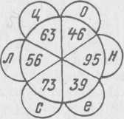

|  |  |  |  |  |  |  |
| --- | --- | --- | --- | --- | --- | --- |
| *Слагаемое* | ***25*** |  | ***23*** | ***37*** |  | ***57*** |
| *Слагаемое* | *48* | ***18*** |  | *58* | *79* |  |
| *Сумма* |  | ***69*** | ***79*** |  | *82* | *96* |
| *Числа* |  |  |  |  |  |  |
| *Буквы* |  |  |  |  |  |  |

**Работа № 24.**

*Прочитай. Спиши, добавляя в предложение по два или три слова.*

Наш класс (какой?) ... Солнышко (какое?) ... Моя самая любимая сказка (какая?) ... Мне нравятся игры (какие?)…. Мне больше всего нравится цвет ( какой?)……

____________________________________________________________________________________________________________________________________________________________________________________________________________________________________________________________________________________________________________________

*Задача.*

9 струн натянули на 3 балалайки. Сколько струн на каждой балалайке?

|  |  |  |  |  |  |  |  |  |  |  |  |  |  |  |  |  |  |  |  |  |  |  |  |  |  |  |  |  |
| --- | --- | --- | --- | --- | --- | --- | --- | --- | --- | --- | --- | --- | --- | --- | --- | --- | --- | --- | --- | --- | --- | --- | --- | --- | --- | --- | --- | --- |
|  |  |  |  |  |  |  |  |  |  |  |  |  |  |  |  |  |  |  |  |  |  |  |  |  |  |  |  |  |
|  |  |  |  |  |  |  |  |  |  |  |  |  |  |  |  |  |  |  |  |  |  |  |  |  |  |  |  |  |
|  |  |  |  |  |  |  |  |  |  |  |  |  |  |  |  |  |  |  |  |  |  |  |  |  |  |  |  |  |
|  |  |  |  |  |  |  |  |  |  |  |  |  |  |  |  |  |  |  |  |  |  |  |  |  |  |  |  |  |
|  |  |  |  |  |  |  |  |  |  |  |  |  |  |  |  |  |  |  |  |  |  |  |  |  |  |  |  |  |
|  |  |  |  |  |  |  |  |  |  |  |  |  |  |  |  |  |  |  |  |  |  |  |  |  |  |  |  |  |

*Реши пример.*

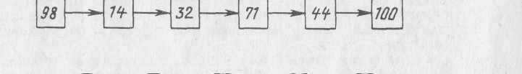

Машина выполняет действия сложения и вычитания, восстанови знаки действия и числа.



**Работа № 25.**

***Только математика.***

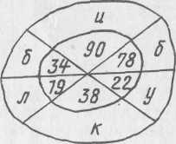

1. Маленькое, сдобное, колечко съедобное. Я одна тебя не съем, разделю ребятам всем. Что это такое?

|  |  |  |  |  |  |  |
| --- | --- | --- | --- | --- | --- | --- |
| *Уменьшаемое* | ***52*** | *35* |  | *86* |  | ***99*** |
| *Вычитаемое* | ***18*** |  | ***29*** | ***67*** | ***25*** |  |
| *Разность* |  | *13* | ***59*** |  | ***65*** | ***6*** |
| *числа* |  |  |  |  |  |  |
| *буквы* |  |  |  |  |  |  |

2. Поработай счетной машинкой.

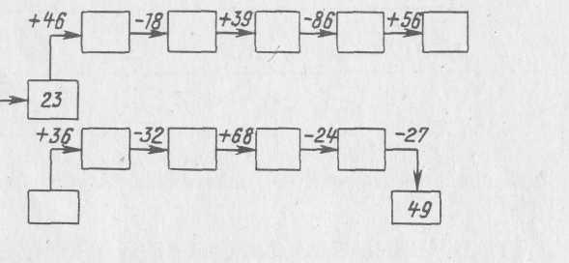

3. . Вычисли удобным способом, замени числа буквами. Объясни правописание полученного слова.

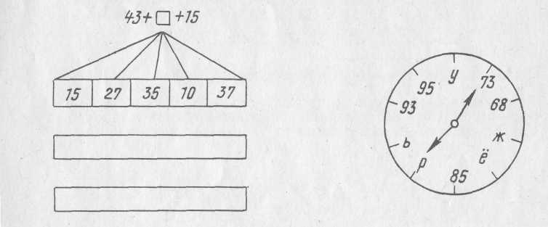

4. . Полосатый Котофей пригласил к себе гостей: Чебурашку вместе с Геной, Айболита с королевой, бабку с дедкой, внучку с Жучкой, Буратино с Почемучкой. Лишь один гость заблудился, к Котофею не явился. Кто же этот странный гость, ты ответь на мой вопрос? На этот шифр ты посмотри и быстро нам ответ запиши.

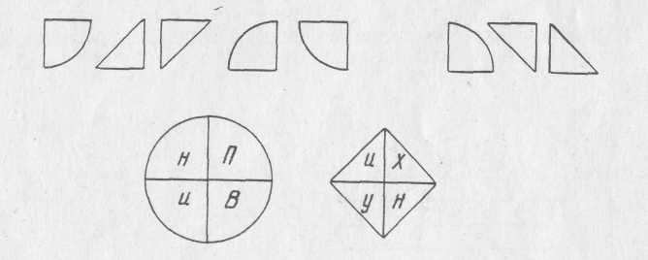

**Работа № 26.**

***Только русский язык.***

**1. Игра «Как называется место, где...»:**

*Допишите место, где происходит действие.*

продают хлеб — *булочная ( ж. р.)*

стригут — __________________________________________

продают конфеты — _____________________________________

шьют одежду — ___________________________________________

вас лечат — _______________________________________________

дают на время книги — _____________________________________

зимой выращивают овощи —___________________________________

хранят автомобили — ________________________________________

держат самолеты — _________________________________________

дома готовят еду — _________________________________________

работают клоуны — __________________________________________

1. **Какое слово в каждой строчке является лишним?**

*Подчеркни лишнее слово. Объясни почему?*

Свинья, овца, бык, антилопа. – *антилопа – дикое животное*

Окунь, дельфин, карась, сом. ______________________________________________

Сорока, тритон, червяк, стриж. _____________________________________________

Заяц, беляк, кролик, русак_________________________________________________

Питон, анаконда, гадюка, хамелеон._________________________________________

Орел, страус, гриф, сокол.______________________________________________________

Альбатрос, ворона, чайка, буревестник______________________________________

Колли, болонка, собака, такса. _____________________________________________

Кобра, птица, змея, ящерица.____________________________________________________

**3. Слова в словах.**

Найдите слова в словах.

ХОРОВОД *(хор, ров, овод),* ВОЛОСЫ *(________________________)*

ШПАГАТ *(_______________________),* ЯРМАРКА *(__________________________)*

ЯБЛОКО *(____________________ __)* ГОЛОСА *(_____________________________)*

БУЙВОЛ *(______________________)* ПОЛОСА *(____________________________)*

**4. «Проверьте Незнайку»**

Незнайка играл в слова, составляя из двух слов одно. Проверьте, правильно ли он составил слова? Исправь ошибки.

ПОЛ + ОСЫ = ПОЛОСЫ **ЗУБ** + **Ь** + Я = **ЗУБЬЯ**

КОЛ + ОСЫ = КОЛОСЫ , **ДУБ** + Ь + **Я** = **ДУБЬЯ**

ВОЛ + ОСЫ = ВОЛОСЫ

**5. «А что это у человека?»**

Запишите слова-ответы.

У птицы это крыло — у человека *(руки, мн. ч.)*

У зверя лапа — у человека _____________________*(.______________)*

У собаки морда — у человека_________________ *(_______________)*

У конфеты фантик —у человека________________ *(_______________)*

У подводной лодки перископ — у человека_________________ *(______________)*

У льва пасть — у человека________________ (_______________*)*

У машины мотор — у человека________________ *(__________________ )*

**Работа № 27.**

**Только математика.**

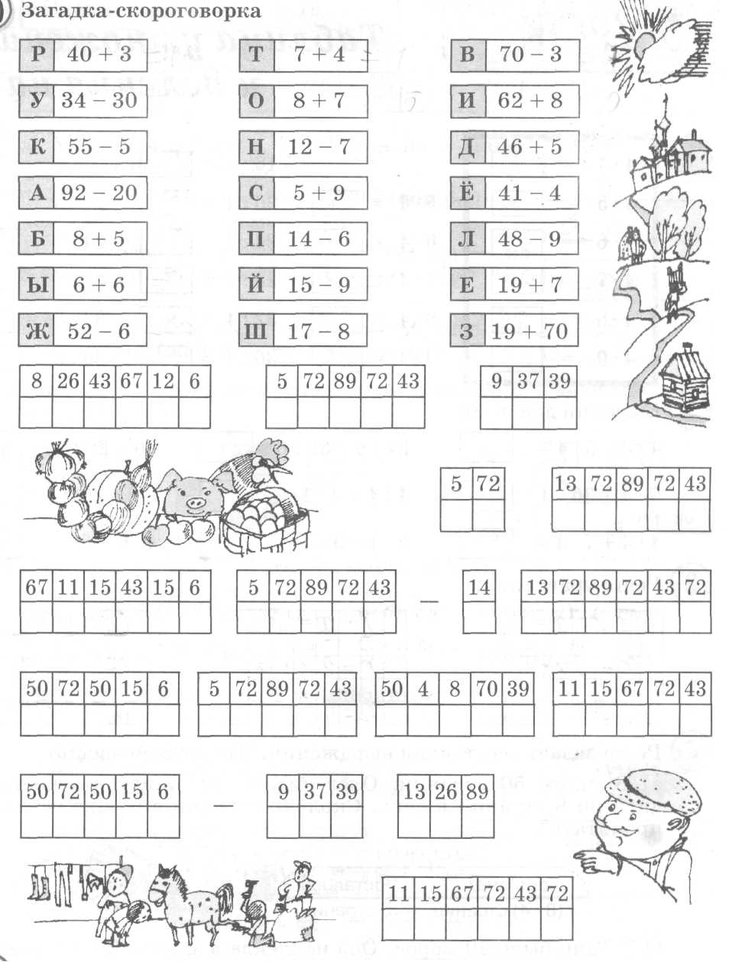

**Работа № 28.**

**Только русский язык.**

**1. Замените слово признак в словосочетаниях синонимом ( близким по смыслу)**

Наточенный нож — острый нож,

острый слух — ________________________________________

чистый воздух —_______________________________________

чистое небо — ________________________________________

худая кошка —________________________________________

худое ведро — ________________________________________

**2. Образуй слова с непроизносимой согласной**

Честь—___________________,доблесть—___________________, звезда — __________________, чудеса —____________________ .

**3. Задачи-игры «Восстанови справедливость»**

*Злой колдун поменял у слов определения, и получилось вот что.*

*Восстановите справедливость - верните определения своим «владель­цам».*

Неуклюжий как крот *неуклюжий медведь*

Верный как слон ___________________________________________

Неповоротливый как собака ________________________________________

Хитрый как бык _________________________________________

Слепой как пес __________________________________________

Длинный как заяц _________________________________________

Трусливый как медведь __________________________________________

Вороватый как жираф __________________________________________

Злой как лиса ___________________________________________

Упрямый как сорока _________________________________________

**4.** **«Кто какой?»**

*Запишите словосочетания, используя слово* ***как***

голодный олень *голодный как волк*

трусливый медведь___________________________________________

хитрая ёж __________________________________________

шустрая змея ___________________________________________

неуклюжий лиса __________________________________________

пестрая ящерица _________________________________________

рогатый заяц __________________________________________

**5. «Кто это?»**

*К слову признак припишите назва­ние животного.*

грязный _____________________ горбатый ._____________________

хитрая..._____________________ пушистая _____________________

трусливый .___________________ колючий ._______________________

шустрый..___________________ упрямый.______________________

толстокожий _________________ ядовитая _______________________

пятнистый .___________________ рогатый _______________________

**Работа № 29.**

**Только математика.**

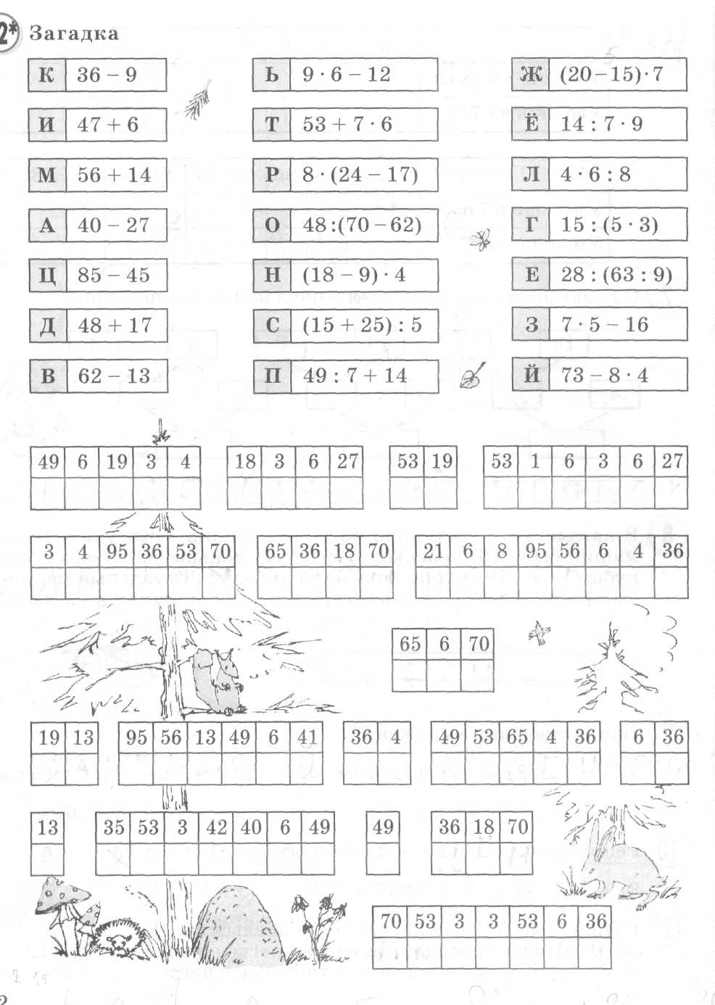

**Повышенной сложности.**

**Работа № 30.**

**Только русский язык.**

**1. Добавь словечко.**

*Прочитайте текст. Спиши, дополните его глаголами. Подчеркни подлежащее и сказуемое.*

Январь. Хорошая погода. На дворе морозец. Заснеженный парк. У входа в дом старинные колонны. Пологие ступеньки в снегу.

________________________________________________________________________________________________________________________________________________________________________________________________________________________________________________________________________________________________________________________

**2.Действие или предмет.**

*Подчеркни в предложении слова действия.*

1. В избе печь, чтобы пироги печь.
2. Снежное покрывало все поле покрывало.
3. Катюша в хоре запевала, она все песни запевала.
4. Иди домой, но сначала коридор домой.
5. В углу раздался детский плач. И кто-то вдруг сказал: «Не плачь!»

6)Стою на нашем берегу. Покой границы берегу.

**3. Допиши слова действия**

Звон, звонкий. __________позвонит_____

Ход, походка. ________________________________

Слом, ломкий. _______________________________

Холод, холодный._________________________

Стар, старик, _________________________   
Отгадка, загадка, __________________________

Смотр, просмотр,. _________________________  
 Бег, бегущий , _____________________________

Свет, светлый______________________________

Садик, сад, ___________________________

Варенье, вареный. __________________________